**Assignment 18.1:**

**Load data to dataframe:**

**Holidays data:**

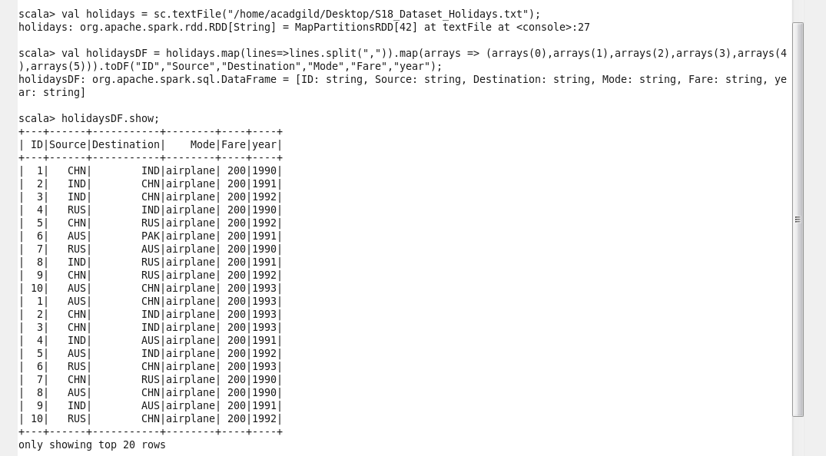

**transport data:**

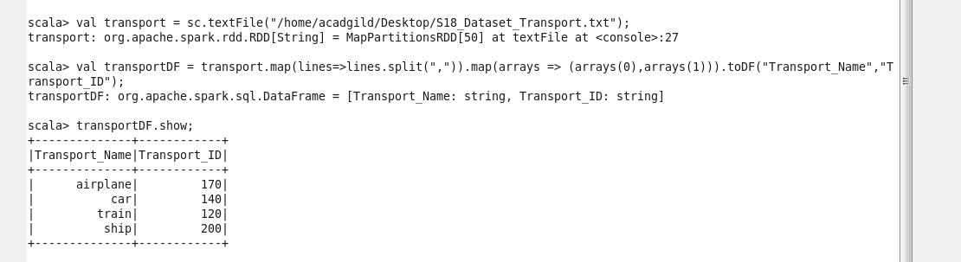

**User data:**

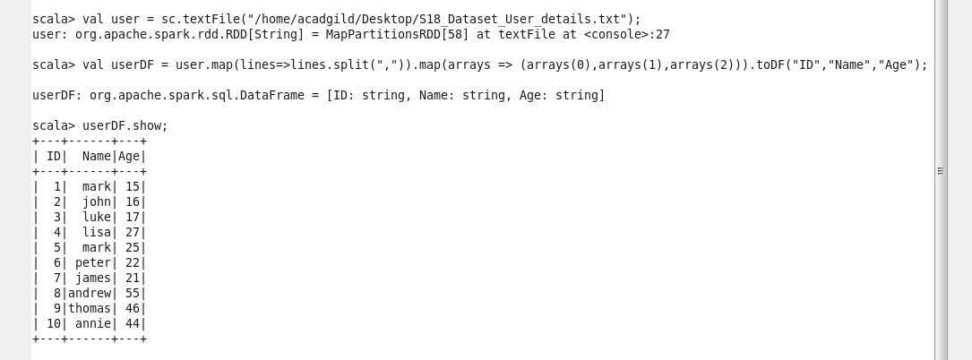

Creating temporary view from all above three dataframes:

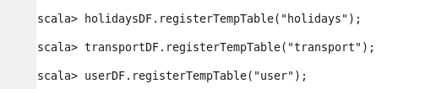

All datasets loaded in to temporary tables.

1. What is the distribution of the total number of air-travelers per year

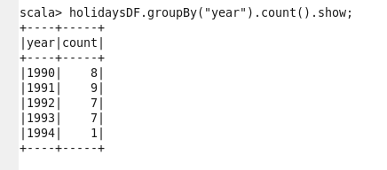

1. What is the total air distance covered by each user per year

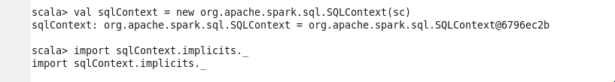

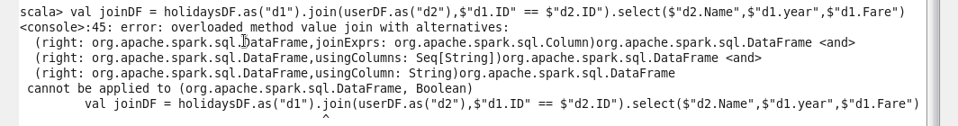

1. Which user has travelled the target distance till date



1. What is the most preferred destination for all users

